# Business Requirements Document (BRD)

## Feature: Introduction of "Archived" Status for Invoices

## 1. Objective

This document outlines the requirements for introducing a new status, "Archived", to the invoice lifecycle in the system. The purpose of this status is to mark invoices that are no longer needed for further processing. Once archived, an invoice becomes completely read-only, preventing any further modifications, approvals, postings, or routing actions. The feature aims to help users maintain a cleaner workspace and reduce clutter by removing inactive invoices from active workflows without deleting them.

## 2. Scope

This enhancement applies to the following invoice modules:  
✅ Production Invoices  
✅ Media Invoices  
✅ PDF-based Broadcast Invoices  
❌ EDI-based Broadcast Invoices (excluded)  
  
It will be reflected across:  
- Invoice UI (individual record view)  
- Manage Invoices UI (list view)  
- Vendor Reports and other reporting modules  
  
Additionally, a new group rule will be introduced:  
- Manage Archive Status: Controls which users can archive or unarchive invoices. If the user does not have this permission, the Archive/Unarchive actions will be hidden or disabled.

## 3. Functional Requirements

### 3.1 Eligible Status Transitions

|  |  |  |
| --- | --- | --- |
| Current Status | Can Be Archived? | Notes |
| Discrepant | ✅ Yes |  |
| Pending Approval | ✅ Yes |  |
| Approved | ✅ Yes |  |
| Posted | ❌ No | Archive option hidden once posted |
| Archived | 🔁 Can be unarchived | Reprocess the invoice as new Invoice.  if invoice was approved at any level, System will revert all approvals and will+ reprocess invoice as new invoice. This reprocessing will ensure that all system level validations are applied on the invoice . |

- When unarchived, the system will reprocess the invoice as mentioned above.  
- .

### 3.2 UI Behavior: Invoice UI (Single Invoice View)

- Once an invoice is archived:  
 - The entire invoice becomes read-only  
 - All standard action buttons (Save, Post, Route, Approve, etc.) are hidden  
 - Only the "Unarchive" (if the user is authorized) and “Close” button will be displayed   
  
- The "Archive" button:  
 - Is shown only for invoices in Discrepant, Pending Approval, or Approved status  
 - Is visible only to users with the group rule "Manage Archive Status"  
 - Is disabled or hidden for all others

### 3.3 UI Behavior: Manage Invoices (Grid/List View)

- For invoices in Archived status:  
 - All row-level or bulk actions (Edit, Post, Approve, Route, Delete, etc.) are disabled  
 - Only the View option is available  
- Archived invoices will not appear on any existing screens i.e. Gadgets Manage Invoice document, vendor reports etc.  
 - a new user interface will be developed to view Archived invoices.

## 4. Open Questions

1. Should Routing Remain Enabled for Archived Invoices?  
 - Currently, the design hides all actions except Unarchive.  
 - If routing is needed for archived items (e.g., for audit or tracking), this needs to be clarified.

[Asim Jamil]: routing button will not be available for archived invoices, user will have to unarchive it to route if needed.   
  
2. Filter Behavior for Archived Invoices  
 - Currently planned to exclude archived invoices from default loads  
 - Should there be a global toggle (e.g., “Include Archived”) or a dedicated filter dropdown?

[Asim Jamil]: no filter needed. Archived invoices will not be visible on any existing screen, i.e. Gadgets, manage invoice documents, and reports.   
we will create separate menu / UI option to view Archive invoices. Users can view Archived invoices only on the new UI which will be developed specifically for Archived invoices.

## 5. Group Rule: Manage Archive Status

A new group rule will be added to control access to archiving and unarchiving functionality:  
  
Rule Name: Manage Archive Status  
  
- Purpose: Determines which users are authorized to archive or unarchive invoices.  
- Applies To:  
 - Production invoices  
 - Media invoices  
 - PDF-based Broadcast invoices  
- Does Not Apply To:  
 - EDI-based Broadcast invoices  
- Behavior:  
 - If the user has this permission:  
 - Archive and Unarchive buttons will be enabled  
 - If the user does not have this permission:  
 - Buttons will be hidden or disabled

## 6. Reporting & Visibility

- The Archived status will be treated like any other status (e.g., Approved, Posted) in:  
 - Vendor Reports  
 - Invoice Management UI  
 - Invoice UI header/status fields  
 - Any internal or exported reporting modules  
- No special formatting or visual indicators will be applied — only the status value will be used to indicate archive state.

## 7. Audit Logging

|  |  |  |
| --- | --- | --- |
| Action | Logged? | Details Captured |
| Archive | ✅ Yes | User ID, Timestamp, Invoice ID, Original Status |
| Unarchive | ✅ Yes | User ID, Timestamp, Invoice ID, Restored Status |

- These entries will be stored in the audit log or a dedicated event log table.

## 8 - Database Changes: DB to Fill this after Design session.

## 9. Non-Functional Requirements

- Performance: Archiving and unarchiving operations must not affect system performance or search behavior.  
- Security: Archiving logic must be enforced at the backend to prevent unauthorized access via API or browser manipulation.  
- Compatibility: All existing integrations and downstream processes will continue to ignore archived invoices, as they cannot be posted.  
  
  
**10. UI Mockup / Flow**

Group Rule UI:A new group rule titled **“Manage Invoice Archive/Unarchive”** will be introduced and applied across all relevant modules, including Media, PDF-based Broadcast, and Production. Users will only see and be able to perform **Archive** or **Unarchive** actions on the UI if they belong to a group that has access to this permission.  
  
Note: what is current order of group rules on this UI, it should be order by Group rule description. Please fix it along with this change.

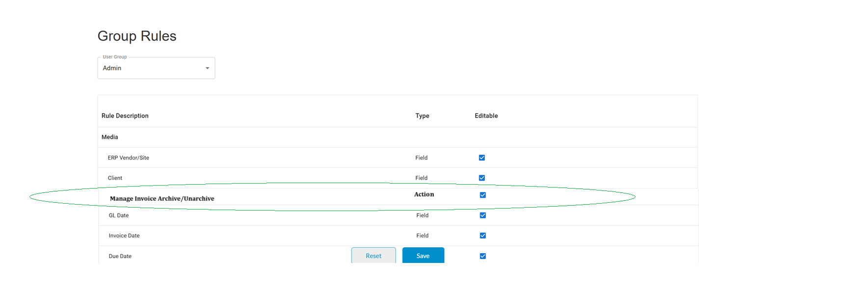Invoice UI.Two new action buttons “**Archive”** and **“Unarchive”** will be added to the Invoice UI. These buttons will be available for all modules **except** EDI-based invoices. Their visibility and functionality are governed by both the invoice status and the group’s permissions.

**1. Archive Button**

The **Archive** button will be displayed and enabled only when:

* The invoice is **not in Posted status**, and
* The user’s group has the **“Manage Invoice Archive/Unarchive”** permission.
* If invoice is posted, Archive button will be hidden, if not posted and user doesn’t have permission, Archive button will be disabled.

**2. Unarchive Button**

The **Unarchive** button will:

* Be visible **only** if the invoice is currently in **Archived** status.
* Be **enabled** only if the user’s group has the **“Manage Invoice Archive/Unarchive”** permission.
* Be **disabled** for users without permission, even if the invoice is archived.

**System Behavior on Clicking Archive Action**

When a user clicks the **Archive** button on the Invoice UI:

* The system will prompt the user with a confirmation message, such as:  
  *“Are you sure you want to archive this invoice? This action will make the invoice read-only.”*
* If the user confirms:
  + The system will immediately update the invoice status to **"Archived"**.
  + The **original state** (e.g., Discrepant, Pending Approval, or Approved) will be intact at this point. .
  + The UI will refresh to reflect the **read-only state**.
  + All action buttons except **Unarchive and close** will be removed from view.
* If the user cancels:
  + No changes will be made to the invoice.
  + The UI and status will remain unchanged.

**Invoice Behavior When Archived**

Once an invoice is marked as **Archived**, the following behavior will apply on the Invoice UI:

* The invoice becomes **completely read-only**.
* All standard action buttons are **hidden**, including:
  + Save
  + Route (need to discuss with US team)
  + Approved
  + Post
  + Any other custom/system actions
* Invoice will be excluded from any validation i.e. for invoice duplication check, for IO consumed amount etc.
* Only the **Unarchive** button will remain visible (and enabled only if the user has permission).
* No editing, routing, approvals, or postings will be allowed.

**Invoice Behavior When Unarchived**

When a user unarchives an invoice:

* The system will prompt the user for **confirmation** before proceeding.
* Upon confirmation, the invoice will be processed as new Invoice, this will ensure that all standard validations are applied on invoice i.e. duplicate invoice number, unavailability of IO/PO amount etc
* All standard action validations applicable to the new invoice will be re-applied. If any discrepancies arise due to these validations, the invoice will be flagged and moved to 'Discrepant' status.
* The invoice will resume its normal lifecycle from that point onward.

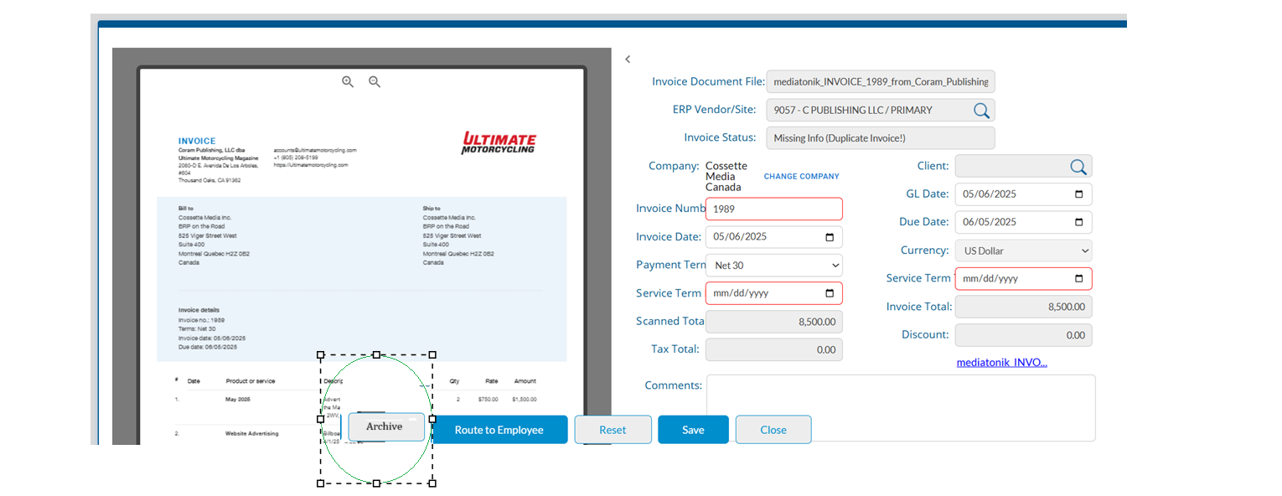

**Image A (Archive Action button)**

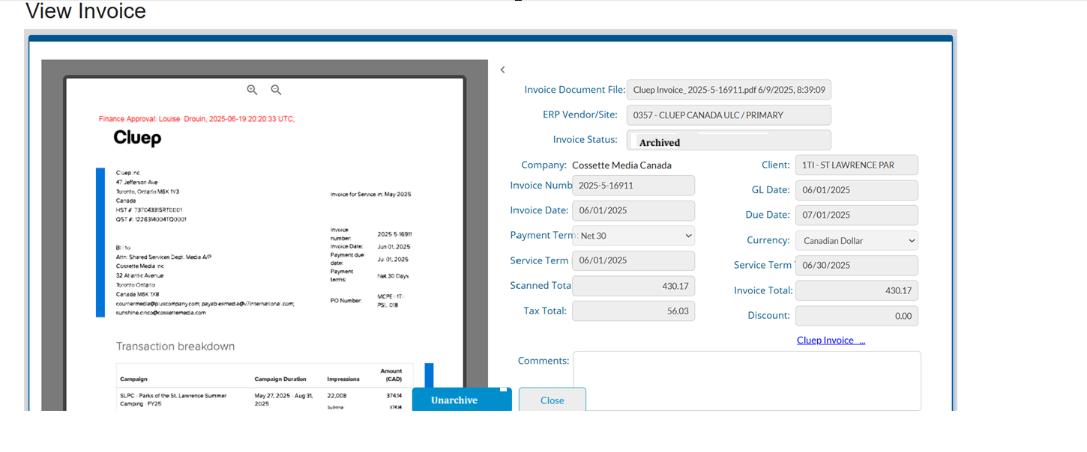

**Image B (Unarchive)**

#### Archived Invoice Visibility. Archived Invoices will not be visible on any existing UI including Gadgets Manage Invoice Document

#### Reports

#### Vendor Invoice

## Vendor Invoices with Payments Archived Invoice UI.

Dedicated **Archived Invoices** pages will be added for each supported module individually including **Media**, **Production**, and **PDF-based Broadcast**. These pages will allow users to view and manage invoices that have been marked as Archived, without impacting the main invoice management workflow.

#### Key Features:

* Each module will have its own **Archived Invoices page**
* Only invoices with status = Archived will be displayed
* Standard filters will be available same as Manage Invoice Document
* All listed invoices will be strictly **read-only**
* **Unarchive** action will be available only for users with the **“Manage Invoice Archive/Unarchive”** permission
* No other invoice actions (Edit, Post, Approve, Route, etc.) will be available

These module-specific pages ensure a clean separation of archived records and give users-controlled access to historical or inactive invoices without cluttering up active workflows.

A new menu item labeled **“Archived Invoices”** will be added under each supported module (Media, Production, and PDF-based Broadcast). This UI will be accessible to all users who have access to the respective module.

The screen will display a list of all invoices currently in Archived status for that specific module. Below is the list of columns that will be shown on this UI:

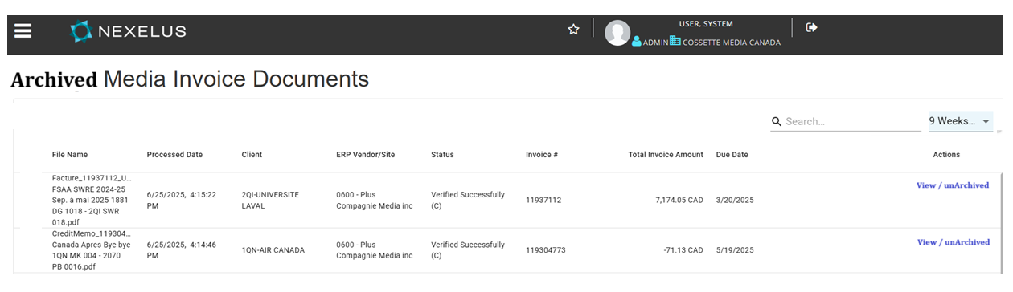

### Available Actions

This screen will offer two action buttons per invoice:

* **View**:  
   Opens the invoice in the full Invoice UI screen when clicked.
* **Unarchive**:  
   Visible only to users with the appropriate **“Manage Invoice Archive/Unarchive”** group permission.  
   When clicked, the system will behave as described in the **“Invoice UI”** section — the invoice will be unarchived, and the results will be refreshed accordingly.

### Search and Filter Behavior

* The filtering functionality will match the behavior of the existing **Manage Invoices UI**.
* On initial load, the system will default to showing invoices from the **last 9 weeks**.
* When a user performs a search, the system will retain the search criteria for the **duration of the session**.

## 11. Out of Scope

- Archiving EDI-based broadcast invoices  
- Bulk archive/unarchive actions  
- Visual highlighting of archived records (e.g., faded rows, color badges)  
- Notifications or warnings when archiving